Stata (this can be easily coded in Python before saving the final output):

* Rename v2 longitude, replace
* Replace population=. If population==-99999
* Drop if population==.
* Sum population, d
* Gen pc=gdp_ppp/population à we can also create gdp pc if population>bottom 10%
* Sum pc, d
* Pctile pct=pc, nq(10) genp(percent) # generate 10 percentiles for gdp pc

List percent pct in 1/10

* This is for the percentiles that don’t show up just using the detail sum
* Save the dataset as a new .csv file

QGIS

* Open country shapefile:

Top menu: Layer/Add Layer/Add vector Layer

Search for the layer in your PC and click add.

* Open .csv file:

Tope menu: Layer/Add Layer/Add Delimited text layer

Search for layer in your PC and this window will pop up (complete as shown under Geometry definition à X field: longitude ; Y field: lat

Click add

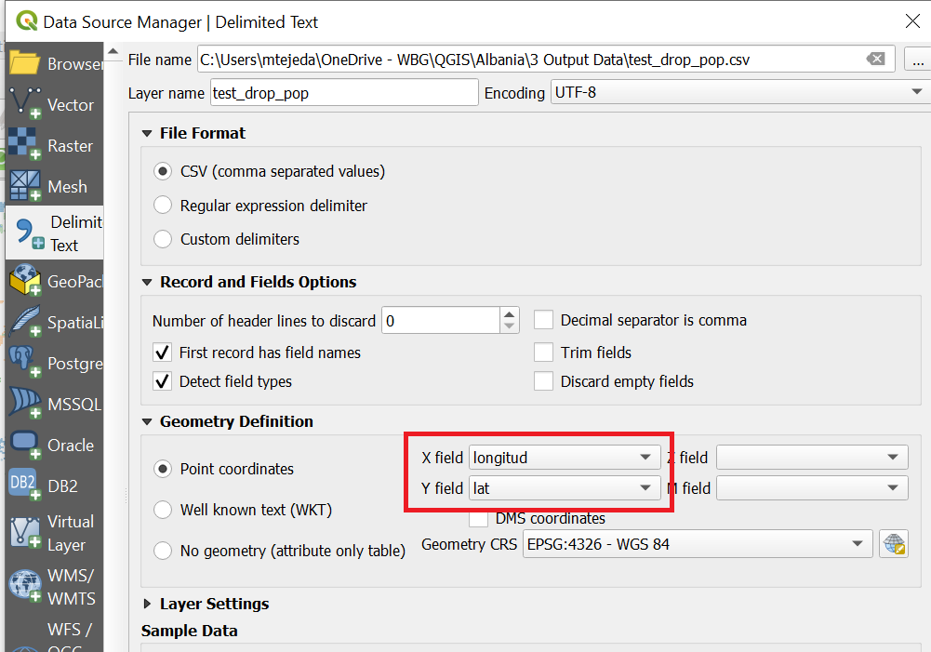

* Buffer creation:

Bottom search icon: search “Buffer” and click on the buffer algorithm

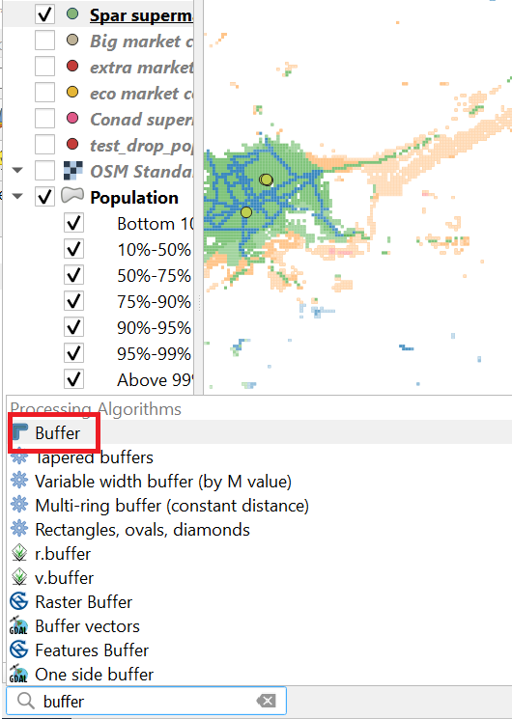

Complete as follows and run the algorithm

* Input layer: the point dataset
* Distance: 0.000415 which is the approximation to 50 meters
* Segments: 1
* End cap style: square
* Join style: miter

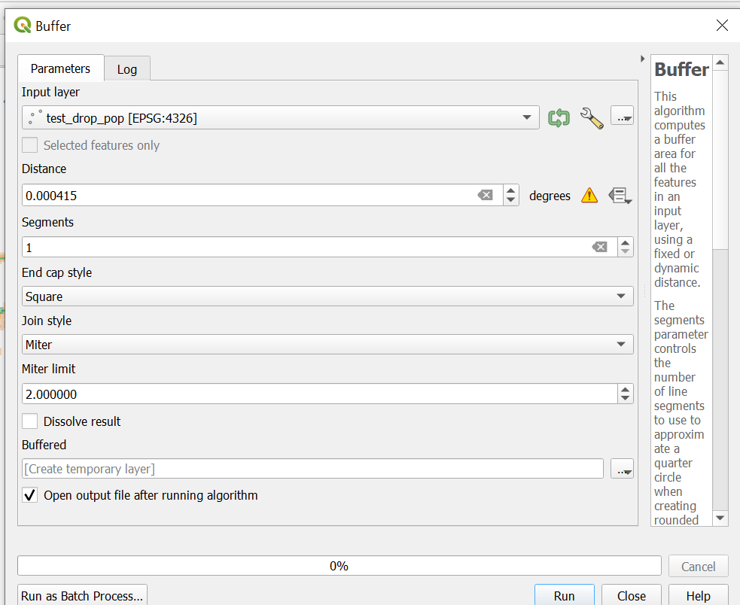

This will create a buffer layer in your Layers menu.

* Duplicate Buffer layer and rename them:
* Right click on the Buffered layer and click on Duplicate layer.
* Double click on each of the buffered layers and change their name under Source/Layer name. One layer to be renamed as “GDP Per capita (Percentiles)” and the other one “Population”
* Check that in the layer panel, population is above GDP PC. If not, manually move it to the top.
* Styling Population and GDP pc layers:

POPULATION

* Click on the name of the layer and the styling menu will be on the right panel.
* Complete as follows (see image below):

Styling: Graduated

Value: population

Change Legends to percentiles.

Change value of thresholds based on the percentiles from Stata

Mode: change to pretty breaks

Classes: 7

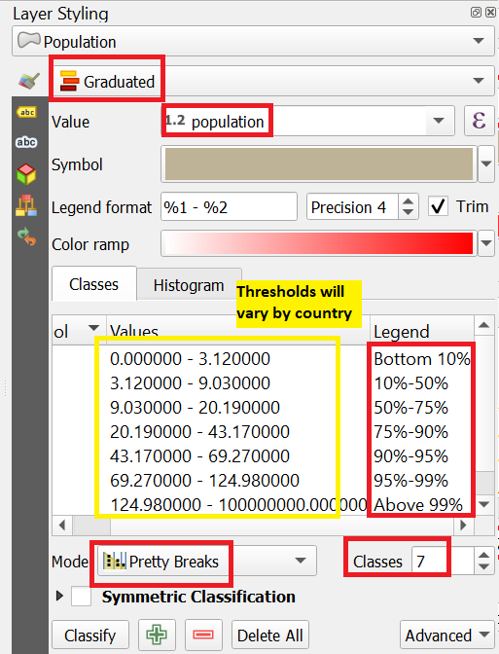

To edit each category, double click in each square of the category and click on Simple Fill.

For population, change all the colors to with (#ffffff)

For Population opacity, replicate the calculations from this document [opacity example](https://worldbankgroup-my.sharepoint.com/personal/mtejeda_ifc_org/Documents/QGIS/Uzbekistan/opacity%20example.xlsx?web=1):

à1-(log (lower threshold by category)/ log(lower threshold highest category))

* Apply this number to opacity: click on the square by category and under Fill change the level of opacity.

GDP Per capita

* Click on the name of the layer and the styling menu will be on the right panel.
* Complete as follows (see image below):

Styling: Graduated

Value: pc

Change Legends to percentiles.

Change value of thresholds based on the percentiles from Stata

Mode: keep Equal count

Classes: 4

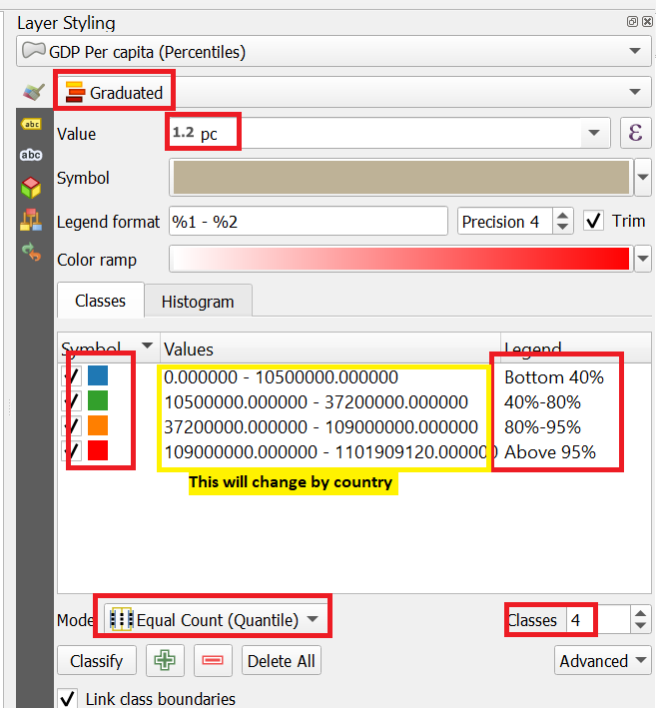

* Color each category as shown above (blue, green, orange, and red)
* Change the values based on the thresholds from Stata code
* Adding other layers:
* For adding top layers such as other .csv or shapefiles, follow the steps at the bottom.
* To edit the symbols, go to the styling panel: Single symbol/ Simple marker and play around with shapes/colors/size. We can also change simple marker for SVG marker or letters, as needed. See examples on the styling in the Uzbekistan map.
* Adding OSM maps (base maps)

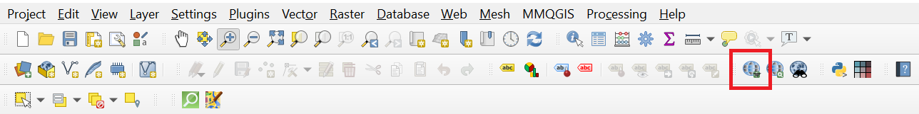

* Top menu select Quick Map Services/ OSM/OSM standard
* For styling the base map, play around with opacity (make sure the base map is above the population and gdp layer. It could also be below if only interested in showing the ocean, for instance.

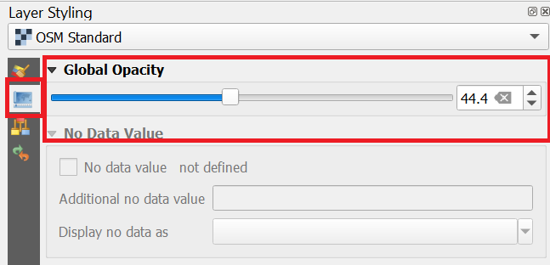

* Adding other features like roads, gas stations, parking

Bottom search icon

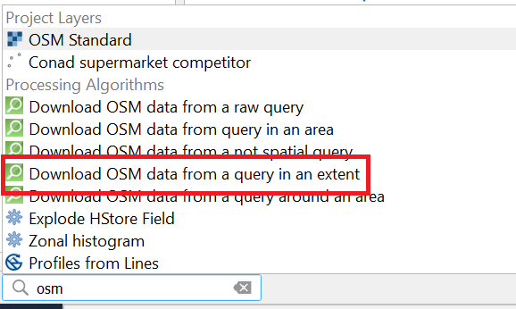

Example for parking:

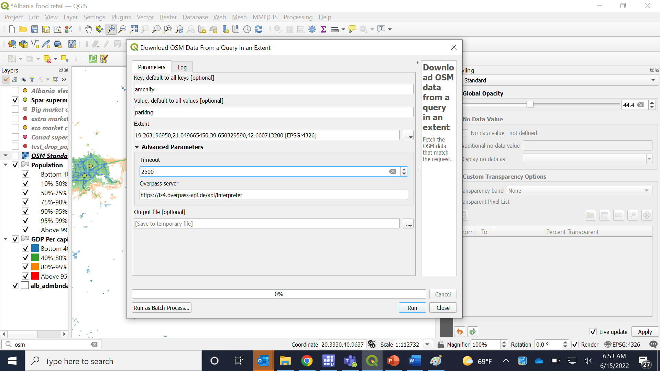

For KEY and VALUE, look at this link <https://wiki.openstreetmap.org/wiki/Map_features#Healthcare_2>

* Search for the feature: bank, parking, gas station, road, etc. Copy KEY (first column) and value (second column)
* Extent: click on … and then layer extent and select the country shapefile
* Increase the timeout and run

It will create new layers (probably more than one). In case there are features as points (banks, parking, etc) just keep the point shapefile and rename. In case there are roads, just keep the line shapefile and rename.

* Layouts: exporting the map
* Top menu: Project/New print layout
* Save it with the map name
* To add the map (that is already styled in the main window) click on the bottom shown below and draw the square.
* Add legend, scale bar and north arrow
* Edit legend in the right panel. Deactivate the auto update under legend items. Add or drop legend items using + or -
* Add text for population
* Add text with source
* Add text to explain that GDP pc is calculated for values where population is above 10%, if that is the case (see example below)
* Add text for city names if needed

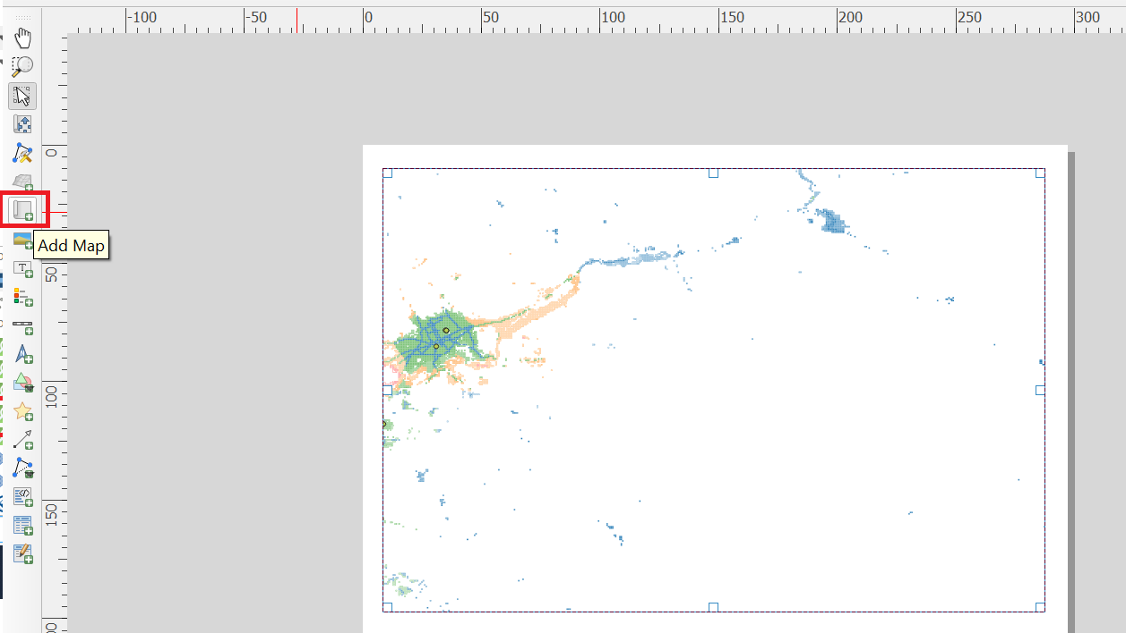

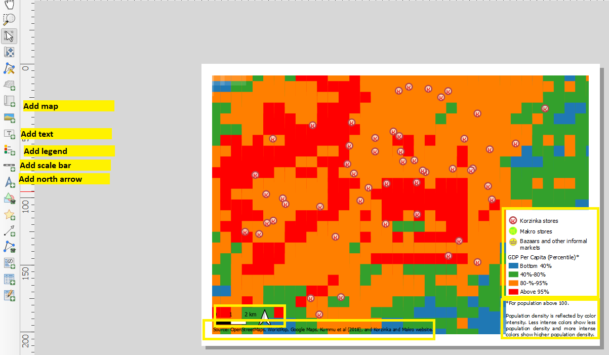

Top menu: Layout/Export as image (or as PPT as needed)